**ASSIGNMENT**

**(WD-HTML)**

# 1) Are the HTML tags and elements the same thing?

Ans: The HTML tags are written in angle brackets while the whole tag with the required output makes an element. So no, HTML tags and elements are different.

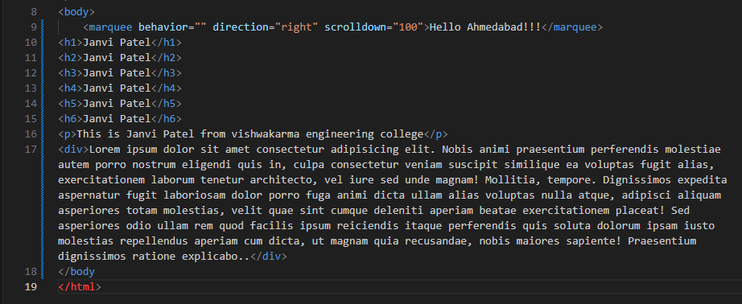

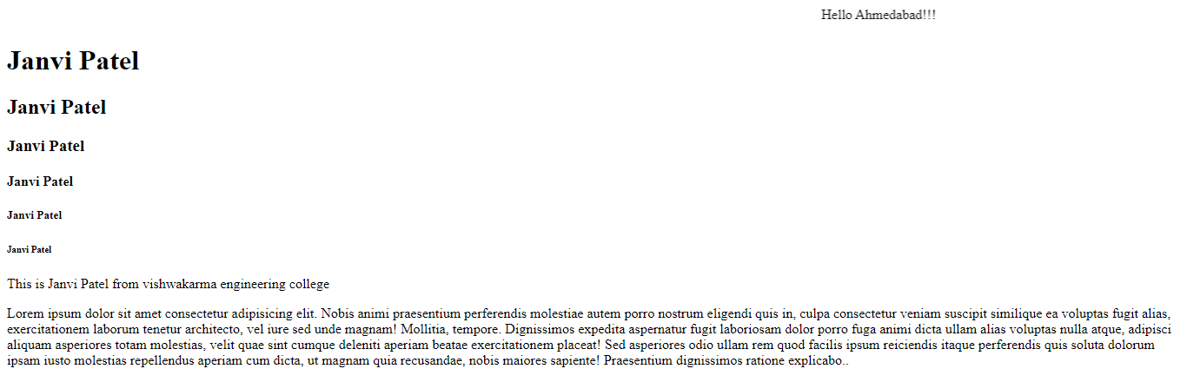

# 2) What are tags and attributes in HTML?

Ans: Tags are the ones that are written in angle brackets and the attributes are the speciality of the tags through which the output can be modified.

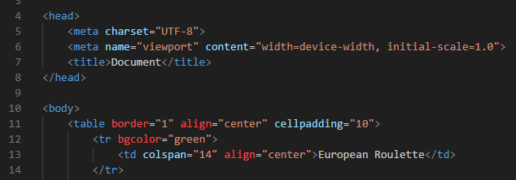

In above shown code the <body>,<title>,<table> are the tags and the specialities of that tags are border ,align ,cellpadding ,colspan .

# 4) What are HTML Entities?

Ans: The HTML Entities represents the symbolic form of the required output. It starts with & and ends with semicolon(;).

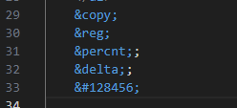



# 5) What are different types of lists in HTML?

Ans: Types of List in HTML

* Ol-Order list
* Ul-Unorder list
* Dl-Data list or Description list

**Order list:** In this list the output is shown in sequence in the form of numbers, alphabets or in Romans.

**Unorder list:** In this list the output is in the form of bullets like square, circle, disk or none.

**Description or Data list:** In this type of list the output shown in the form of data and its definition.

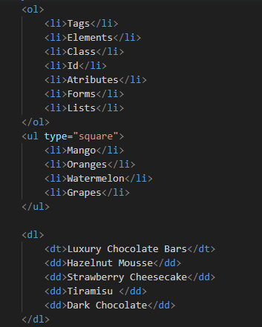

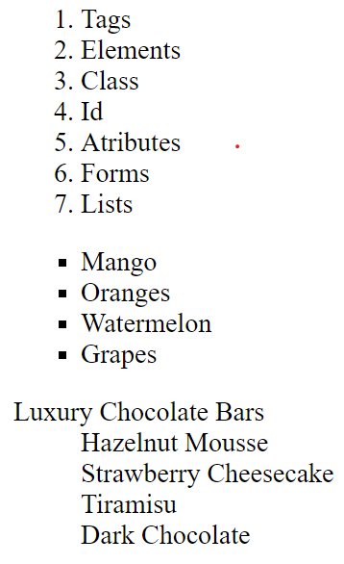

# 6) What is the ‘class’ attribute in HTML?

Ans: The class attribute is used to apply the same style for more than one tag . It makes the code short and easier.

The class name starts with (.) and we can call the class in tag which requires the style applied in the class.

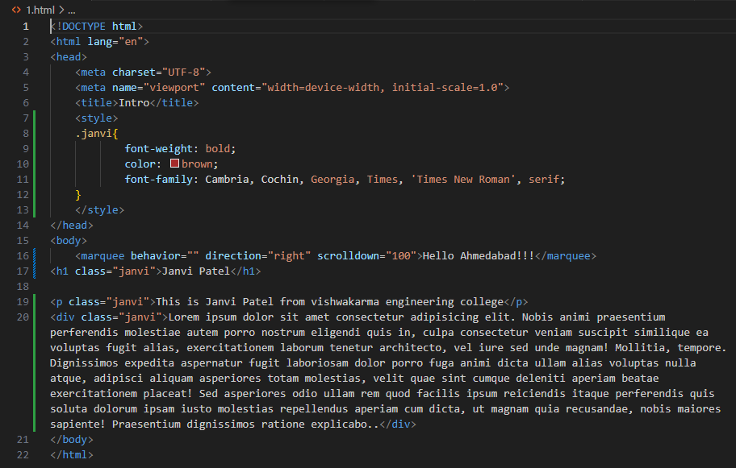

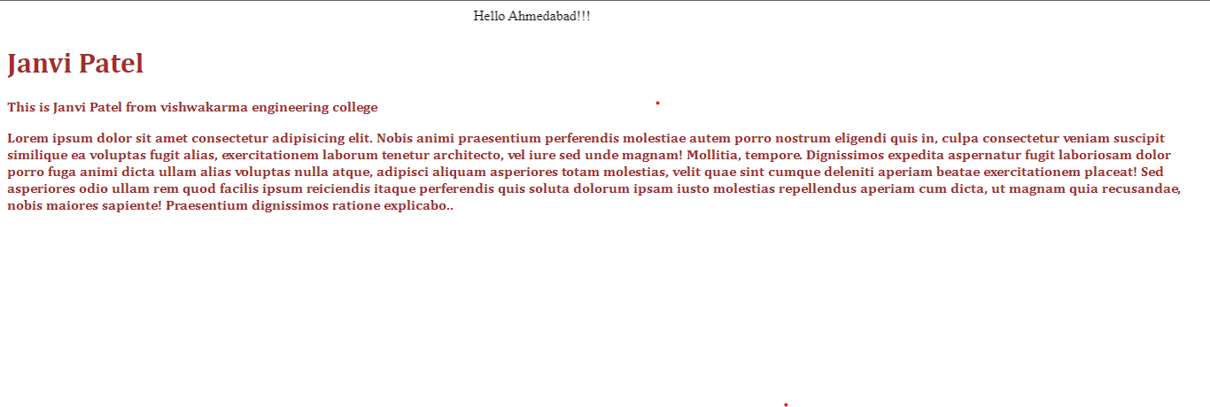

# 7) What is the difference between the ‘id’ attribute and the ‘class’ attribute of HTML elements?

Ans: A **Class**name can be used by multiple HTML elements, while an **ID**name must only be used by one HTML element within the page.

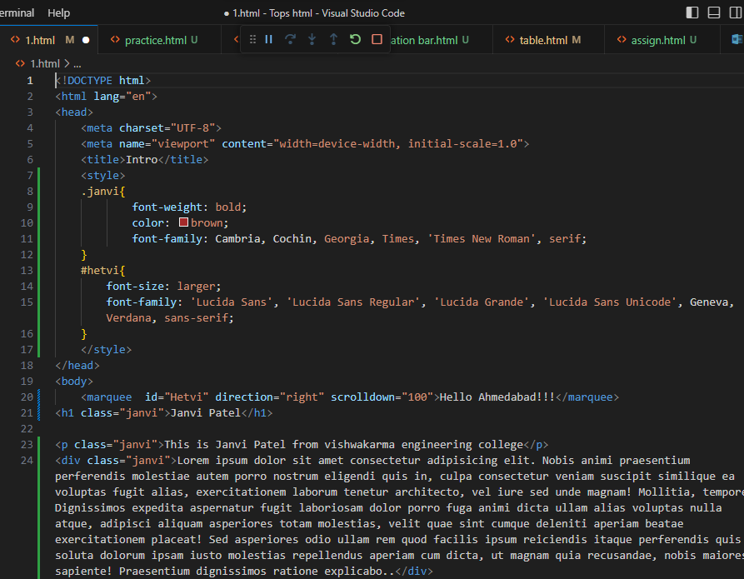

# 8) What are the various formatting tags in HTML?

Ans: The various formatting tags used in html are: Heading tags (h1 to h6), paragraph tag<p>, Division tag<div>, bold tag <b>, Italic tag <i>, Underline tag <u>, emphasize tag <em>, strong tag, Insert tag <ins>, break tag <br>, horizontal tag<hr>, mark tag, Superscript tag <sup>, subscript tag <sub>, marquee tag, predefined tag <pre>.

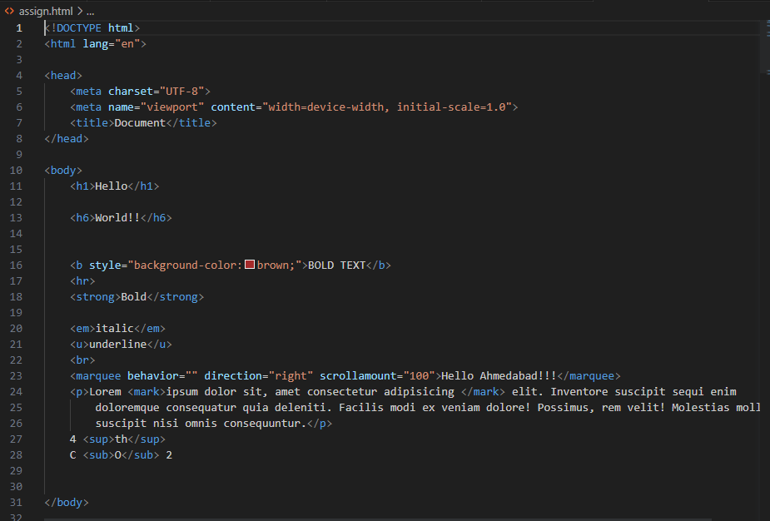

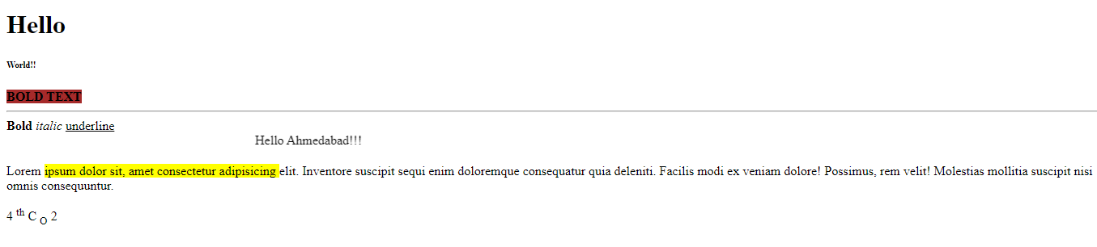

# 9) How is Cell Padding different from Cell Spacing?

Ans: Cell Padding Icrease the space between the cell border and contain of the call. while the cell spacing increase the space between main border and the cell border. This is the basic difference between the Cell Padding and Cell Spacing.

# 

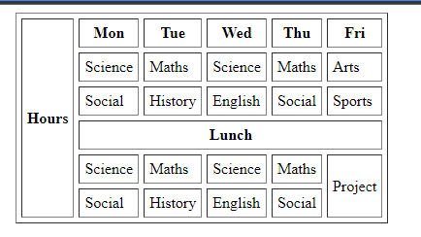

# 10) How can we club two or more rows or columns into a single row

# or column in an HTML table?

Ans: We can club two or more rows in a single row by using the rowspan attribute and the two or more columns can be clubbed into single column by using colspan attribute.

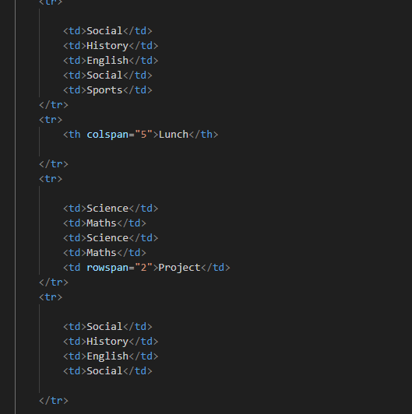

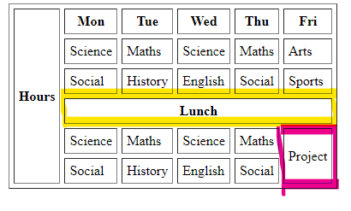

# 11) What is the difference between a block-level element and an inline element?

Ans: The block level element will cover 100% width of the screen while inline element will only cover the required width of the screen.

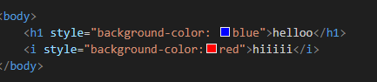

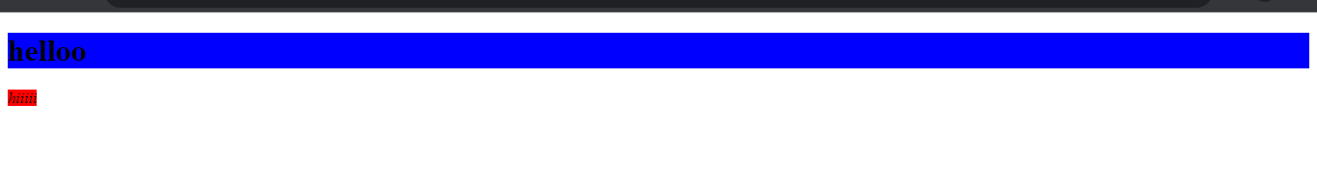

# 12) How to create a Hyperlink in HTML?

Ans: A hyperlink in HTML is created using anchor tag <a href””>…......</a>

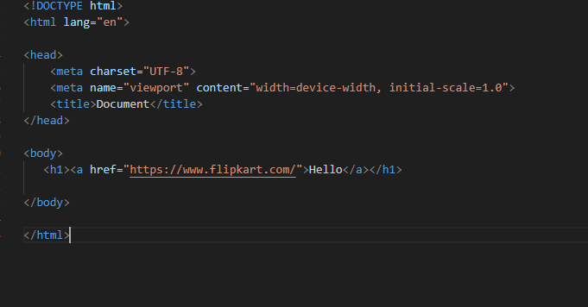

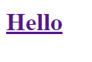

# 13) What is the use of an iframe tag?

Ans: The use of iframe tag is to create a nested webpage i.e., a webpage within a webpage.

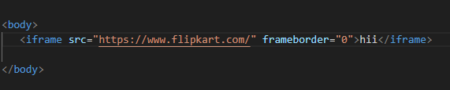

# 14) What is the use of a span tag? Explain with example?

Ans: The span tag is used as a container of the elements. It can be used for styling using class and id attribute.

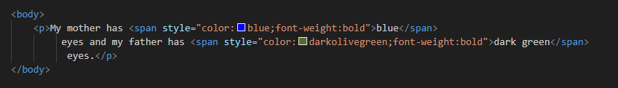



# 15) How to insert a picture into a background image of a web page?

Ans: The background image of a webpage can be inserted using style tag and background image and URL attribute. The path of the image is to be added in URL.

